Site name: Ride Right

Ben Thomason

WDD 130

Overview purpose

This website helps skiers and snowboarders find the right gear for their style and skill level. It offers simple guides and a big gallery of skis and snowboards to make it easier to choose what fits you best. Whether you’re new to the slopes or already experienced, the goal is to help you ride with confidence and have more fun on the mountain.

Audience

People who ski or snowboard, or anyone who wants to start. This includes beginners looking for their first setup, as well as intermediate and advanced riders who want help finding the best gear for their style—whether that’s park, powder, or all-mountain riding.

Logo

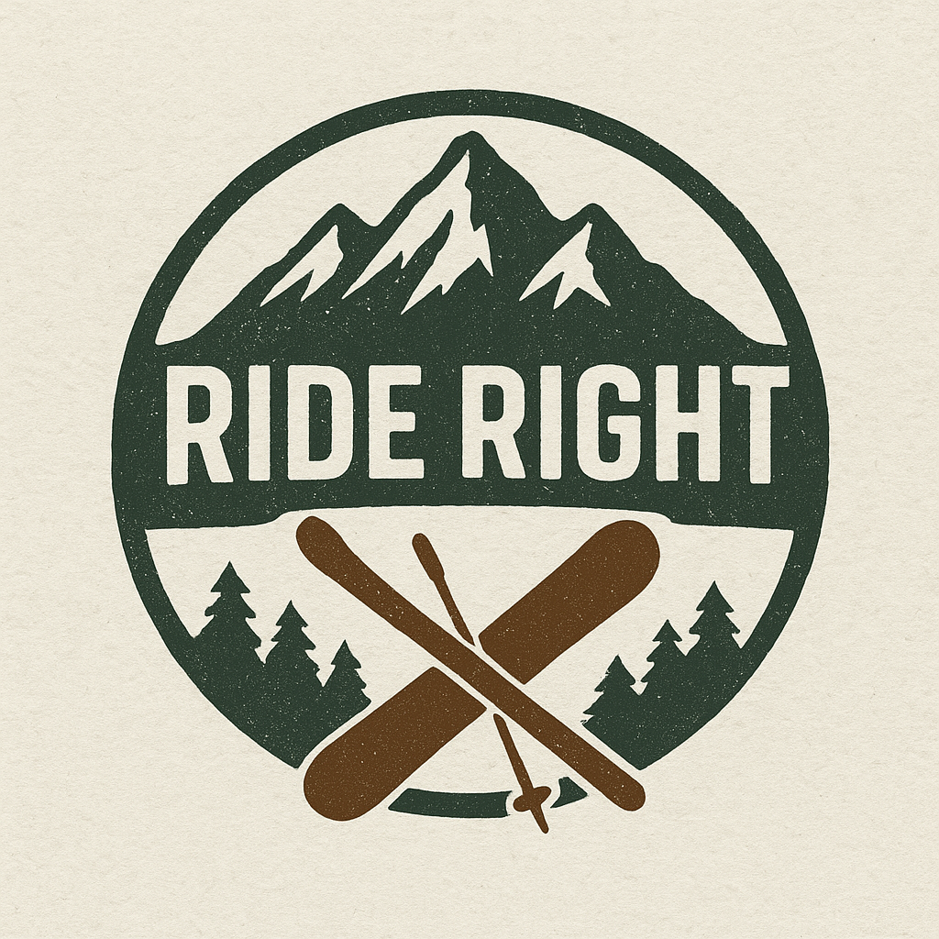

Color Palette

1. **Forest Green** – for headers, buttons, and accents  
    #2F4F4F
2. **Rust Brown** – for highlights and secondary text  
    #8B4513
3. **Off-White** – for background or text contrast  
    #F5F5DC
4. **Slate Gray** – for body text or neutral areas  
    #708090

Heading Font

@import url('https://fonts.googleapis.com/css2?family=Allan:wght@400;700&display=swap');

Paragraph Font

@import url('https://fonts.googleapis.com/css2?family=Arimo:ital,wght@0,400..700;1,400..700&display=swap');

Navigation

Home Skis Snowboards

Content

Cool mountain picture:

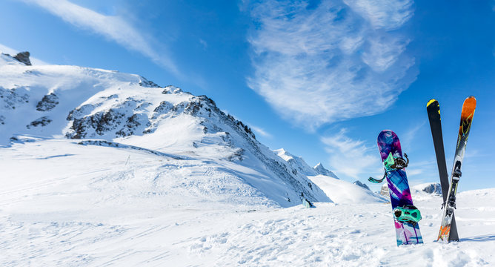

Freestyle

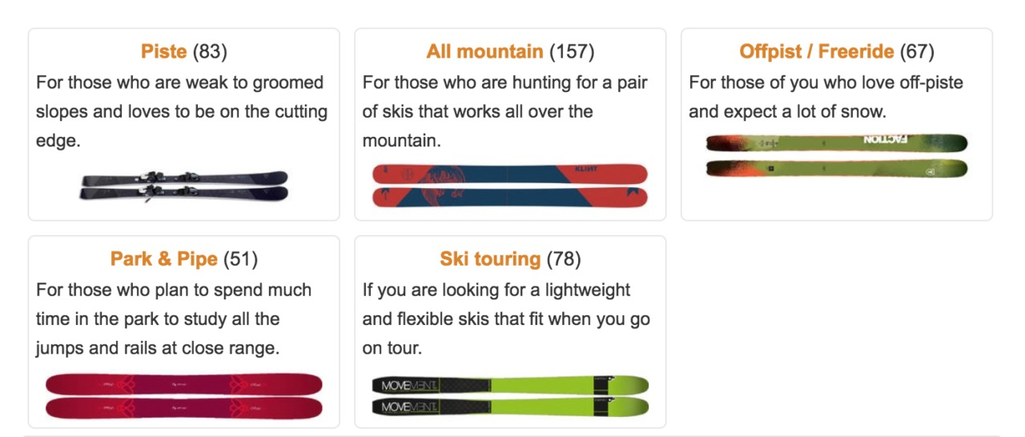

Description: **Freestyle skis** are built for riders who love jumps, tricks, and terrain parks. They’re lightweight, flexible, and usually twin-tipped so you can ski both forward and backward with ease.

All-Mountain



Description: **All-mountain skis** are designed to handle any terrain, from groomed runs to light powder. They offer a balanced mix of stability, control, and versatility, making them a great choice for skiers who like to explore the whole mountain.

Freeride



Description: **Freeride skis** are made for adventurous skiers who love tackling off-trail terrain and deep powder. They’re wider, stiffer, and built to handle variable snow conditions and steep, challenging lines.

Race

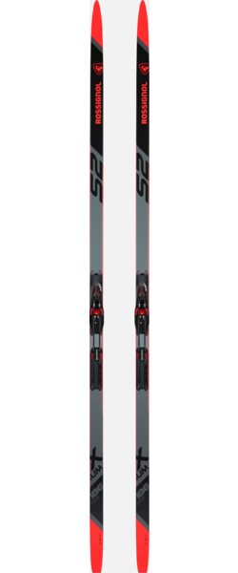

Description: **Race skis** are built for speed, precision, and powerful turns on groomed slopes. They have a stiff flex and narrow waist, giving advanced skiers maximum edge control and responsiveness at high speeds.

All-Mountain

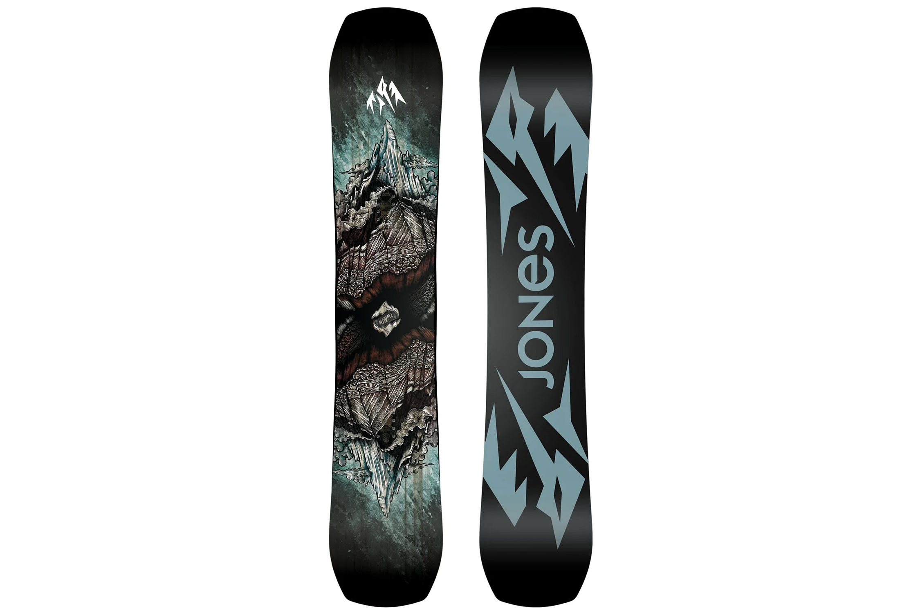

All-mountain boards are versatile and designed to handle any terrain—from groomers to powder runs. They offer a balanced mix of stability, flexibility, and control for riders who like to explore everywhere.

Freeride

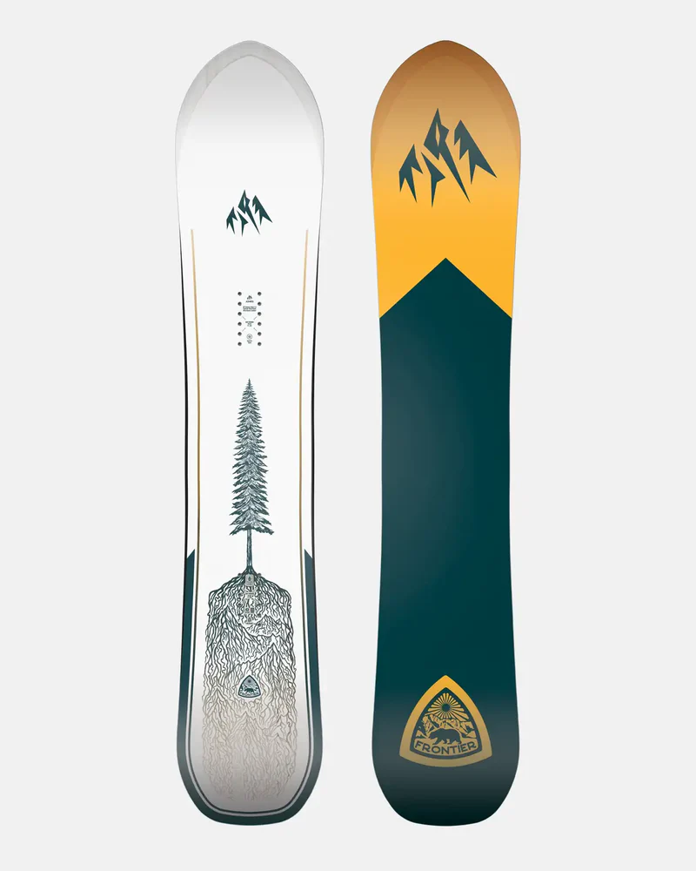

Freeride boards are made for carving through deep powder and steep, off-trail terrain. They’re usually stiffer with a directional shape for strong edge hold and speed in challenging conditions.

Freestyle

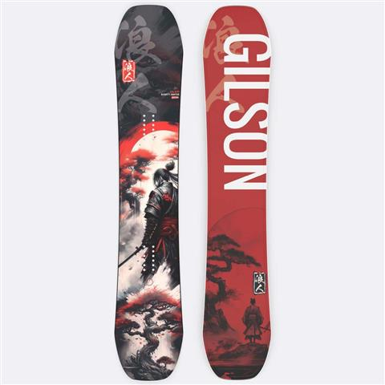

Freestyle boards are light, flexible, and built for jumps, spins, and tricks in the terrain park. Their twin-tip shape makes it easy to ride both regular and switch with smooth control.

Powder

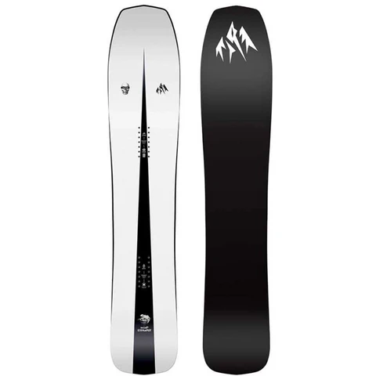

**Powder snowboards** are designed for deep, soft snow days when you want to float effortlessly. They usually have a wider nose, a tapered tail, and a setback stance to keep you gliding smoothly over fresh powder.

Wireframes

Home page Ski page

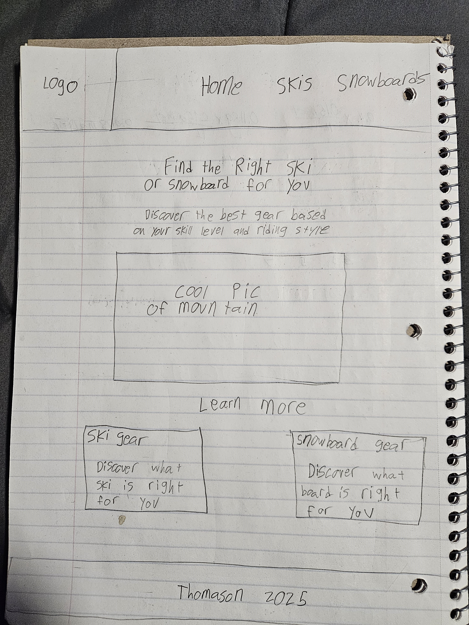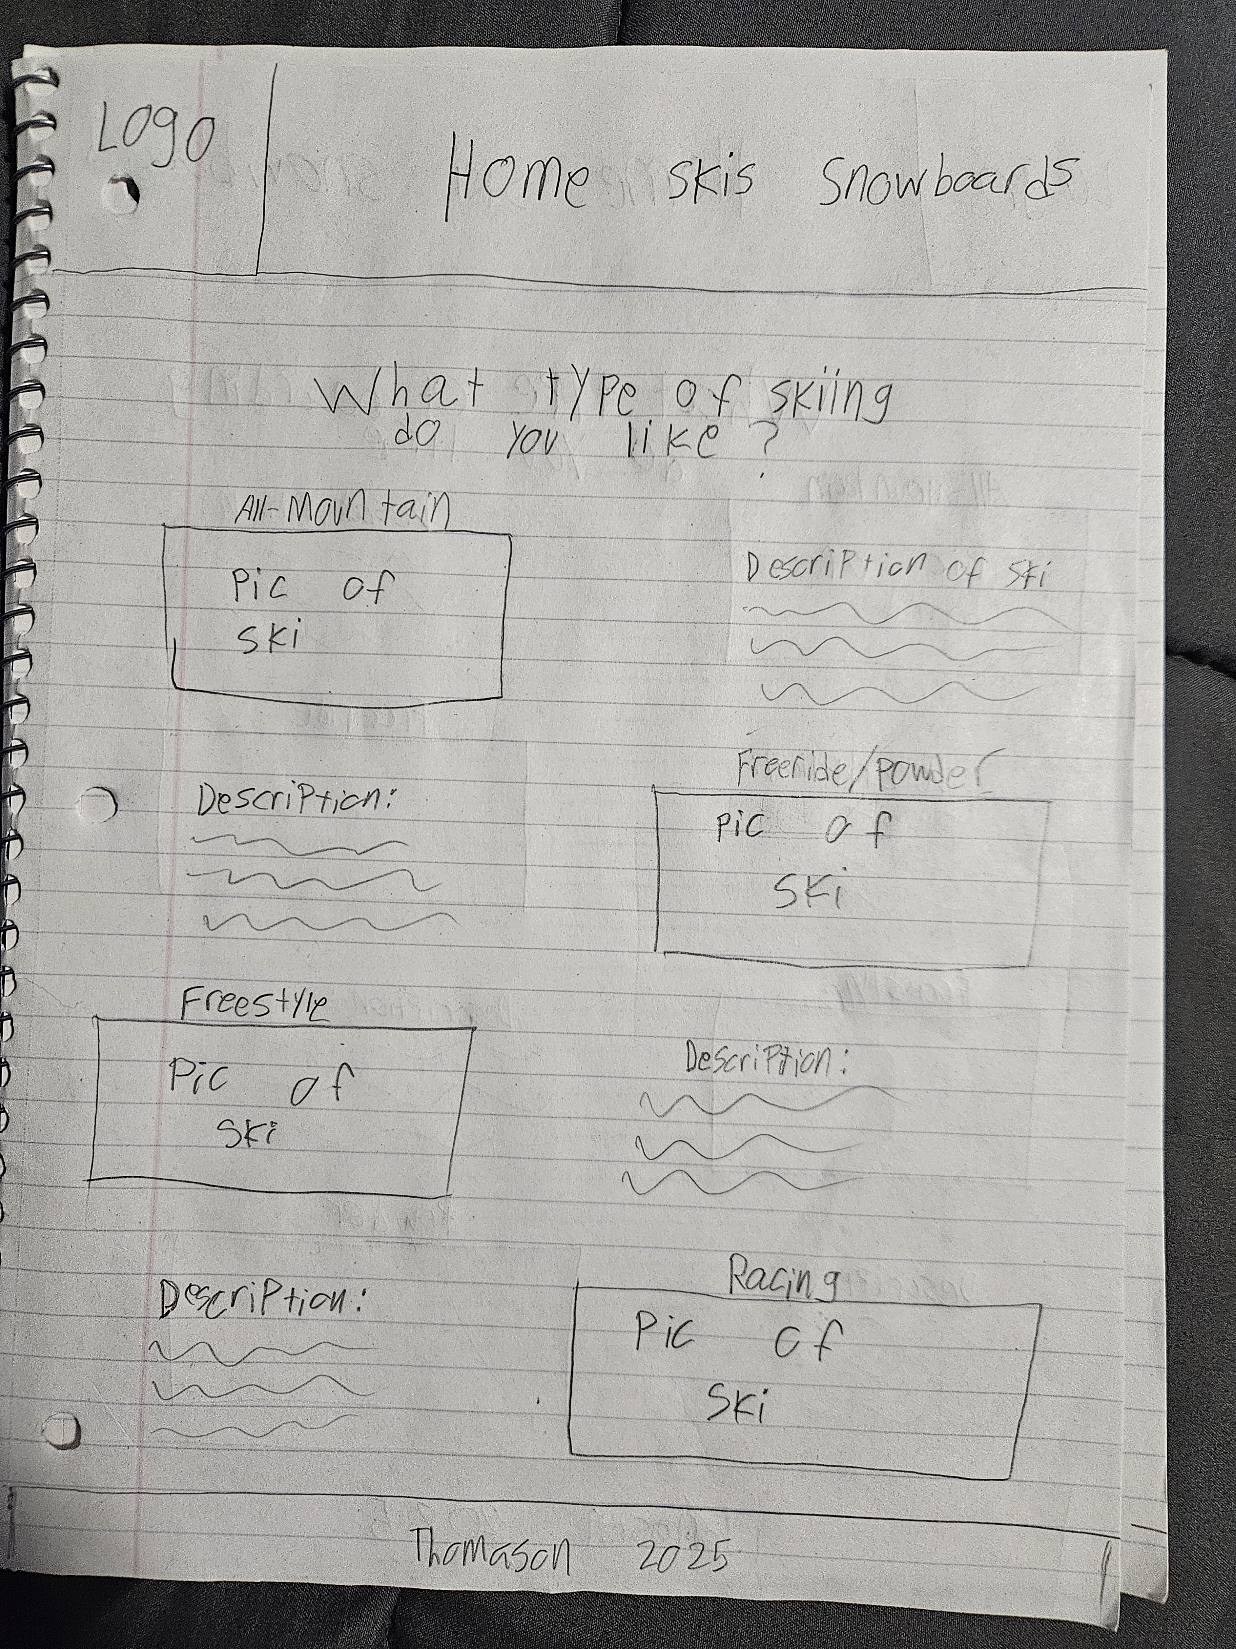

Snowboard page

